PAPER TITLE (please insert your title here, by replacing our text)
(BOOKMAN OLD STYLE, 17PT, BOLD, CAPS, UP TO 70 CHARACTERS)

Author Name (Arial Narrow, 14 pt, bold)
Institution Name (Arial Narrow, 12 pt), Town, Country
Email (Arial Narrow, 12 pt)

Author Name (Arial Narrow, 14 pt, bold)
Institution Name (Arial Narrow, 12 pt), Town, Country
Email (Arial Narrow, 12 pt)

Abstract (please insert your abstract below, by replacing our text)
The paper abstract will be written in Arial Narrow, size 10 pt.
The abstract will be submitted in English version only, and will be approximately 100-250 words and it should emphasize elements like: the paper objectives, the paper background, the research methodology, the methods used in data-collecting process, the expected results and the conclusions of the research.
The abstract aims to emphasize the relevance and the quality of the research. Please do not use references/footnotes within this paragraph.
Keywords: The Keywords will be written in Arial Narrow, size 10 pt., separated by commas. It is recommended to select maximum 5 keywords.

1. INTRODUCTION (ARIAL NARROW, 12 PT, BOLD, CAPS)
The introduction text will be written in Arial Narrow, size 11 pt., including: title (Introduction) and the text of this section which should focus on the present state of the research, the purpose of the work, its significance and the progresses reached so far in the field.

2., 3., 4., ..., n. PAPER SECTIONS (ARIAL NARROW, 12 PT, BOLD, CAPS)
N+1. CONCLUSIONS (ARIAL NARROW, 12 PT, BOLD)
REFERENCES (ARIAL NARROW, 12 PT, BOLD)
References should appear in a separate section at the end of the manuscript, listed in alphabetical order by names of authors and should only include works cited in the text. The references should be listed in APA style.
Examples APA style:

- Book with one author:
Hedrick, J.L. (2009). Effective donor relations. Hoboken, NJ: John Wiley & Sons
- Book by two authors or more:
Kotler, P., Keller, K.L., Brady, M., Goodman, M. & Hansen, T. (2009). Marketing management (1st European ed.). Harlow: Prentice Hall
- Articles in an edited book:
Mcdonalds, A. (1993). Practical methods for the apprehension and sustained containment of supernatural entities. In G. L. Yeager (Ed.), Paranormal and occult studies: Case studies in application (pp. 42–64). London: OtherWorld Books
- Articles and papers published within scientific reviews and journals:
Bigné-Alcañiz, E., Currás-Pérez, R., Ruiz-Mafé, C. & Sanz-Blas, S. (2010). Consumer behavioural intentions in cause-related marketing. The role of identification and social cause involvement. International Review on Public and Non Profit Marketing. 7(2): 127–143
- Articles and papers published within non-scientific reviews, journals and newspapers:
Slapper, G., 2005. Corporate manslaughter: new issues for lawyers. The Times, 3 Sep. p.4b
- Article in an Internet-only journal:
Essnet Validat Foundation. "Methodology for data validation 1.0." 06 2016.
https://ec.europa.eu/eurostat/cros/system/files/methodology_for_data_validation_v1.o_rev_2016_06_fi
al.pdf (accessed 01 2018)
- E-books:
Benjamin, S. Baumer., Daniel, T. Kaplan., Nicholas, J. Horton. Modern Data Science with R. 2017.
https://books.google.ro/books?id=NrddDgAAQBAJ&dq=data+science&hl=ro&source=gbs_navlinks_s
(accessed 2018)
- Internet articles:
Jane, A., Saw, S., & Chan, J. (2009). Detective work and the benefits of colour versus black and white. Journal of Pointless Research, 16, 123–124. Retrieved August 16, 2017, from http://www.pointlessjournal.com/colour_vs_black_and_white.html

NOTE! The article’s text should be inserted in this template. Therefore, after reading the instructions below, please remove them before submitting your article!
Depending on the authors’ preferences, the article could be also divided into sections – the sections will be listed (using 2, 3, …n for sections and 2.1, 2.2,….2.n for subsections).
By accomplishing this, the paper must respect the following requirements:
- The length of the manuscript should not exceed 20 pages, including figures, tables, references and appendices;
- The articles should only be written in English, using Microsoft Word. The font should be Arial Narrow, size 11 pt., Justify alignment, 1.5 line-spacing, 2.54 cm margins on all four sides, including the reference section. The paper will be saved in any available version of Microsoft Word;
- Do not insert page numbers and or any header or footer element within the paper;
- The titles of the sections and sub-sections will be numbered continuously by using Arabic figures, as shown above.
- The section order will begin with section 1. Introduction and will end with section N. Conclusions. References section (REFERENCES) will not be numbered.
- The tables, figures and graphics will be numbered consecutively using Arab numerals with a brief caption; originals of all figures, charts, diagrams, tables and illustrations should be in good quality, sharp, noise-free, and easy-to-read (see the example below for figures/graphs and tables):
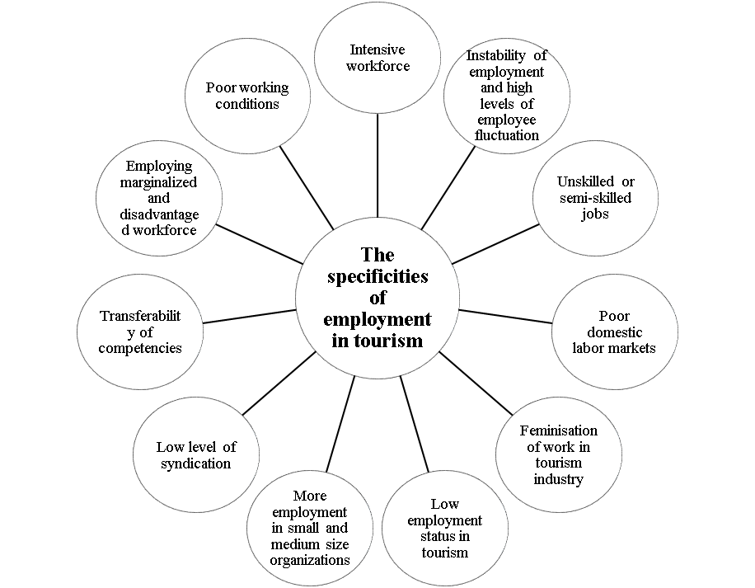
FIGURE/GRAPHIC 1. TITLE HERE
Source: Source here

TABLE 1. TITLE HERE
Source: Source here
- The Maths formulas will be centred and numbered as shown below:
y=f(x) (1)
- The abbreviations and acronyms will be explained one single time, when they occur for the first time in the paper.

- The papers will be submitted via e-mail, at beman_journal@yahoo.com or beman.journal@gmail.com, exclusively in Microsoft Word format

- The submission of a manuscript for publication in the journal implies that it has not been published (except in the form of an abstract or as part of a published lecture, review, or thesis), nor is being considered for publication elsewhere.
- The authors are fully responsible for the whole content of the paper and for the quality of the phrases and sentences used.

IF THE PAPER IS NOT SUBMITTED ACCORDING TO THE CONSIDERATIONS PRESENTED IN THIS MATERIAL, THE ARTICLE MIGHT BE POSTPONED FROM PUBLISHING OR REJECTED!

THANK YOU!

